**Домашне завдання №15**

## **Тестування інтерфейсу користувача (GUI). Тестування вебзастосунків**

**Перший рівень**

| ID number | #1 |
| --- | --- |
| Name | Main page - city is substituted based on the user's location |
| Reporter | Kateryna L |
| Submit Date | 04/03/2023 |
| Summary | When home page opens the city is substituted based on the user's location |
| URL | https://oxford-med.com.ua/ |
| Screenshot |  |
| Platform | Windows |
| Operating System | OS 7 |
| Browser | Chrome 109.0.5414.120 |
| Severity | Major |
| Assigned to | / |
| Priority | Medium |

**Description**

When home page opens the city is substituted based on the user's location

**Steps to reproduce**

> open site https://oxford-med.com.ua/

> look at the city in the upper left corner in the header

**Expected result**

The city in which the user is located shows

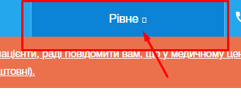

**Actual result**

Kyiv shows

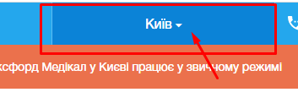

| ID number | #2 |
| --- | --- |
| Name | Main page - the logo |
| Reporter | Kateryna L |
| Submit Date | 04/03/2023 |
| Summary | When you click on the logo on the main page, the main page reopens |
| URL | https://oxford-med.com.ua/ |
| Screenshot |  |
| Platform | Windows |
| Operating System | OS 7 |
| Browser | Chrome 109.0.5414.120 |
| Severity | Major |
| Assigned to | / |
| Priority | Medium |

**Description**

When you click on the logo on the main page, the main page reopens

**Steps to reproduce**

> open site https://oxford-med.com.ua/

> click on the Logo on the Main page

**Expected result**

When you click on the logo on the main page, the main page does not reopen

**Actual result**

When you click on the logo on the main page, the main page reopens

| ID number | #3 |
| --- | --- |
| Name | Main page - the advertising message |
| Reporter | Kateryna L |
| Submit Date | 04/03/2023 |
| Summary | The advertising message displays in red |
| URL | https://oxford-med.com.ua/ |
| Screenshot |  |
| Platform | Windows |
| Operating System | OS 7 |
| Browser | Chrome 109.0.5414.120 |
| Severity | Major |
| Assigned to | / |
| Priority | Medium |

**Description**

When you open main page, the advertising message displays in red

**Steps to reproduce**

> open site https://oxford-med.com.ua/

> look at the advertising message

**Expected result**

The advertising message displays in light green



**Actual result**

The advertising message displays in red

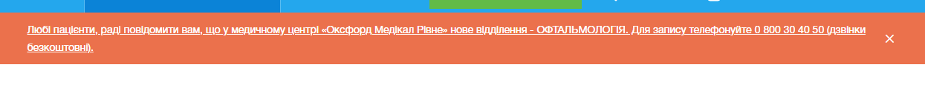

| ID number | #4 |
| --- | --- |
| Name | Authorization form- the assistance buttons |
| Reporter | Kateryna L |
| Submit Date | 04/03/2023 |
| Summary | The assistance buttons have small size labels |
| URL | https://oxford-med.com.ua/ |
| Screenshot |  |
| Platform | Windows |
| Operating System | OS 7 |
| Browser | Chrome 109.0.5414.120 |
| Severity | Major |
| Assigned to | / |
| Priority | Medium |

**Description**

The assistance buttons at Authorization form have small size labels

**Steps to reproduce**

> open site https://oxford-med.com.ua/

> open Authorization form

> look at assistance buttons

**Expected result**

The assistance buttons at Authorization form labels sizes are 15 px

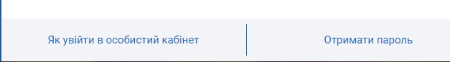

**Actual result**

The assistance buttons at Authorization form labels sizes are 13 px



| ID number | #5 |
| --- | --- |
| Name | Main page - displaying the phone |
| Reporter | Kateryna L |
| Submit Date | 04/03/2023 |
| Summary | The inscription does not fit in the phone field |
| URL | https://oxford-med.com.ua/ |
| Screenshot |  |
| Platform | Windows |
| Operating System | OS 7 |
| Browser | Chrome 109.0.5414.120 |
| Severity | Major |
| Assigned to | / |
| Priority | Medium |

**Description**

When we reduce the browser window the label does not fit the phone field,

**Steps to reproduce**

> open site https://oxford-med.com.ua/

> reduce the browser window to 835x515

> look at phone number in header

**Expected result**

The label in phone number field moves to the second line

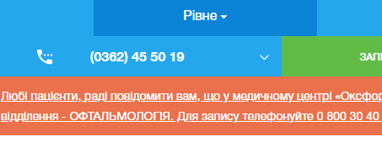

**Actual result**

The label does not fit the phone field

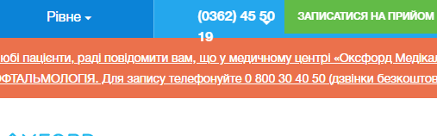

**Другій рівень**

Всі наведені вище баги присутні і в браузерах Opera та Mozilla FireFox

**Третій рівень**

номер телефону у хедері

font: 16px/24px HelveticaNeue-Bold,sans-serif;

color: #fff;

background: transparent

ім’я асистента при виклику чата допомоги

* color: #ccc;
* font-size: 13px;
* background-color: unset;
* font-family: Roboto

кнопка “інші міста” у футері сайту

* font: 14px/24px HelveticaNeue, sans-serif;
* color: #24a7ed;
* background: #ebebeb;

Placeholder “ім’я” у формі “ЗАПИСАТИСЯ НА ПРИЙОМ”

* font: 14px/18px HelveticaNeue, sans-serif;
* color: #6d6d6d;
* *background-color: field;*